**Desk Top Structural Roof Appraisal Information Request Form**

**Client Details**

|  |  |
| --- | --- |
| Company Name: |  |
| Company Ref/Project No: |  |

**Property Location Property Type**

|  |  |  |  |  |  |  |  |
| --- | --- | --- | --- | --- | --- | --- | --- |
| Install Address Line 1 |  | |  | 3 Storey Det/Terrace |  | Barn |  |
| Install Address Line 2 |  | |  | 2 Storey Det/Terrace |  | Warehouse |  |
| Install Address Line 3 |  | |  | Bungalow |  | Industrial Unit |  |
| Install Postcode: |  | |  | Garage |  | School |  |
| Nearest City/Town | Choose an item. | |  |  |  |  |  |
| Distance to the Sea **(km)**  **https://www.doogal.co.uk/DistanceToSea** | | **(km)** |  | **Other (Please specify)** | | | |
| Height Above Sea Level **(m)**  [**https://www.freemaptools.com/elevation-finder.htm**](https://www.freemaptools.com/elevation-finder.htm) | | **(m)** |  | **Approx. Age of the Property (Years)** | | |  |

(Please use these links and provide the required information)

**Property Information**

|  |  |  |  |  |  |  |
| --- | --- | --- | --- | --- | --- | --- |
| **Roof Type:** | Pitched |  | Mono Pitch |  | Flat |  |
|  | Curved |  | Hipped |  |  |  |

|  |  |  |  |  |  |
| --- | --- | --- | --- | --- | --- |
| **Property Size:** | Building Length | **(m)** |  | Height to Eaves | **(m)** |
| **See Ref A** | Building Width | **(m)** |  | Height to Ridge | **(m)** |
|  | Roof Pitch | **(Deg)** |  | Parapet Height (Flat roofs only) | **(m)** |
|  | Distance to the nearest Building | **(m)** |  | Height of nearest obstruction. (E.g. Higher Building o Tree) | **(m)**  **Approx.** |
|  |  |  |  |  |  |
|  | **Where a building ridge line does not run through the middle of the building, we would ask that you refer to Ref B and complete the section below** | | | | |
|  | Roof Pitch A | **(Deg)** |  | Roof Pitch B | **(Deg)** |
|  | Building Half Width A | **(m)** |  | Building Half Width B | **(m)** |

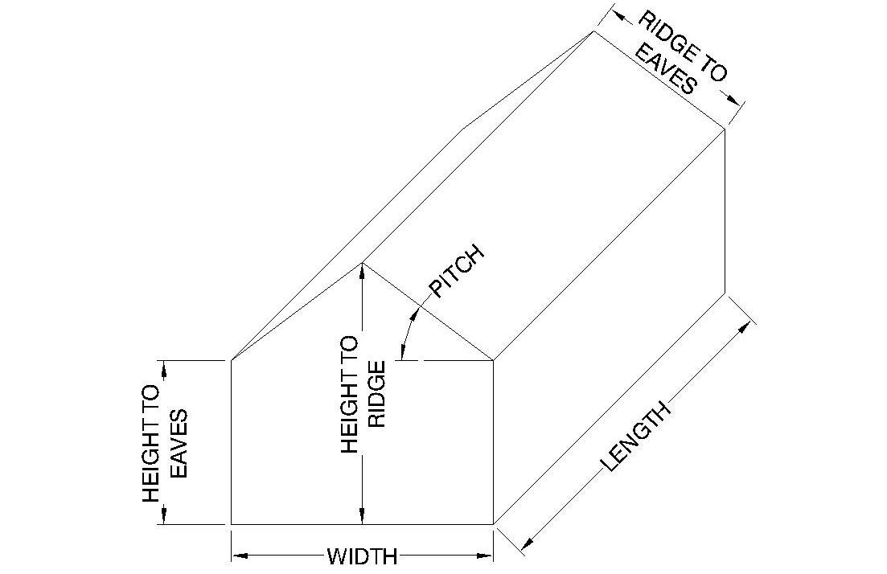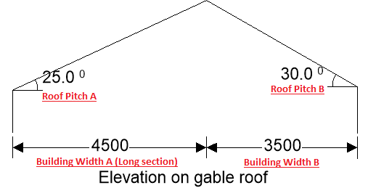

**Ref: A Ref: B**

**Roof Information**

|  |  |  |  |  |  |  |
| --- | --- | --- | --- | --- | --- | --- |
| Roof Construction | 1. | Tile/Slate, Battons, Felt, Trusses/Rafters. | 2. | Trapezoidal Sheet, Insulation, Trusses/Rafter. | 3. | Corrigated Metal Sheets, Trusses/Rafter. |
|  | 3. | Cement Fibre/Asbestos Sheets, Trusses/Rafters. | 4. | (FLAT) Felt/Bitumen, Sarking, Truss/Roof Joists. | 5. | (FLAT) Trapezoidal Sheets, Truss/Roof Joist |
|  | 6. | Other: (Please specify) | | | | |

**Trussed Roof Member Sizes**

|  |  |  |  |  |  |  |
| --- | --- | --- | --- | --- | --- | --- |
| Rafter Size: | Width | (mm) | Depth | (mm) | Length | (mm) |
| Web Size: | Width | (mm) | Depth | (mm) | Length | (mm) |
| Bottom Chord | Width | (mm) | Depth | (mm) | Length | (mm) |
| Truss Spacing | | (mm) |  |  |  |  |

**Cut Timber Roof Member Sizes**

|  |  |  |  |  |  |  |
| --- | --- | --- | --- | --- | --- | --- |
| Purlin Size: | Width | (mm) | Depth | (mm) | Length | (mm) |
| Purling Spacing Between Centers | | (mm) | Span Between Supporting Walls. | | | (mm) |
| Rafter Size: | Width | (mm) | Depth | (mm) | Length | (mm) |
| Rafter Spacing: |  | (mm) |  |  |  |  |
| Ceiling Binder | Width | (mm) | Depth | (mm) | Length | (mm) |
| Span between supporting walls. | | (mm) |  |  |  |  |

**Flat Roof Member Sizes**

|  |  |  |  |  |  |  |
| --- | --- | --- | --- | --- | --- | --- |
| Roof Joist Size: | Width |  | Depth |  | Length | (mm) |
|  | Span | (mm) | Span Between Intermediate Supports | | | (mm) |

**Please note that in order to complete the flat roof surveys all roof make-up information is required.**

**Steel Frame / Portal Frame Building Member Sizes**

|  |  |  |  |  |  |  |
| --- | --- | --- | --- | --- | --- | --- |
| Portal Frame/Column: | Width | (mm) | Depth | (mm) | Length | (mm) |
| Portal Frame/Roof Beam: | Width | (mm) | Depth | (mm) | Length | (mm) |
| Purlin Size: | Width | (mm) | Depth | (mm) | Length | (mm) |
| Portal Frame Height **B**: |  | | Purlin Spacing **C**: | | (mm) | |
| Portal Frame Spacing **D**: |  | | Portal Frame Width **E**: | |  | |

Please provide diagram if unsure and include photos of internal construction.

 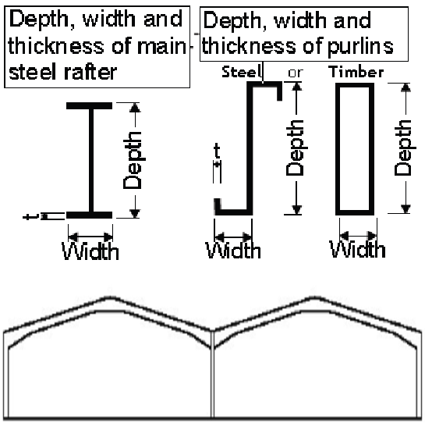

**Single Bay Portal Frame** **Double Bay Portal Frame**

(Please provide width dimensions of each bay)

**Visual Roof Inspection by Client**

|  |  |
| --- | --- |
| Are there any signs of deflection to the existing roof slopes? | **Yes/No** |
| Are there any signs of rot/damage to the internal roof structure? | **Yes/No** |
| Are there any signs of anything which would cause for concern when fitting panels to the roof? | **Yes/No** |
| Are there any dwarf walls/props which support the purlins? | **Yes/No** |
| Is there any signs of structural work which has been carried out to the roof structure before? | **Yes/No** |

**Photograph Checklist** **Panel Information**

|  |  |  |  |  |  |  |  |
| --- | --- | --- | --- | --- | --- | --- | --- |
| North Elevation |  |  | East Elevation |  |  | Panel Length | **(m)** |
| South Elevation |  |  | West Elevation |  |  | Panel Width | **(m)** |
| Roof Trusses |  |  | Purlins |  |  | Panel Weight | **(kg)** |
| Rafter |  |  | Steel Sections |  |  | **(Or attach data sheet)** |  |
| Steel Connections |  |  | Panel Diagram (incl. Dims) |  |  |  |  |
| Roof Surface |  |  | Panel Arrangement Diagram |  |  |  |  |

**Additional Notes.**

**Additional Notes.**

**ONCE THE FORM IS COMPLETE PLEASE RETURN TO**

[**info@bmgsurveysltd.co.uk**](mailto:info@bmgsurveysltd.co.uk)

**PLEASE ATTACH ALL OF THE REQUESTED PHOTOS AND A PANEL LAYOUT DIAGRAM**